**Scenario: Migration**

* Let’s assume that organization LT Corp Wants to start using AWS.
* They have existing infrastructure which they use to run the applications  
  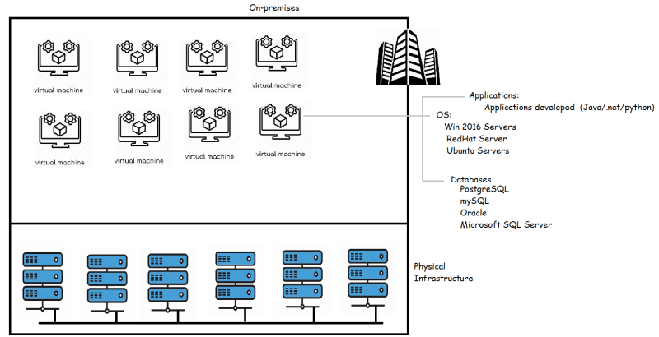
* The basic idea of LT Corp is to move all of the applications to the AWS.  
  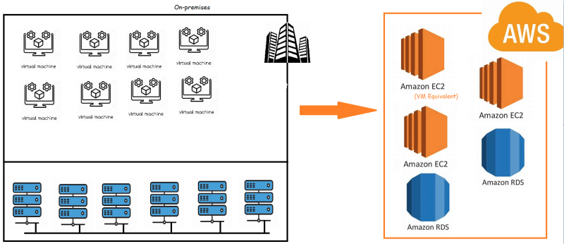

**Execution Plan From 10,000 Feet**

* In AWS, we have a Service called as
* *Server Migration Service (SMS)* using which we migrate Virtual Machines from on-premises to AWS EC2 instances
* *Database Migration Service (DMS)* using which we can migrate Databses into AWS RDS instances
* AWS SMS:
* AWS can migrate Virtual Machines from
  + VMWare vSphere
  + Microsoft Hyper-V/SCVMM
  + Microsoft Azure
* For doing this migration there are requirements & supported OS
* AWS DMS:
* AWS Supports the following Databases to migrate
  + Oracle
  + Microsoft SQL Server
  + Postgres
  + MySQL
  + MongoDB
* Todo’s for unsupported Databases
* Migrate the Virtual Machine and try to run your database as an ec2 instance
* Todo’s for unsupported OS:
* Generally older versions of linux OS are unsupported, so upgrade the existing virtual machines to the supported OS Version
* When we do the migration, we have 3 major activities as admins
* Pre-Migration Tasks
* Migration
* Post-Migration Tasks

**6 Strategies for Migrating Applications to the Cloud (6 R’s)**

* The Strategies are
* Rehosting (Lift and Shift):
  + We would like to move the application to cloud and would expect it to run on same/similar configuration like on-premises.
  + We don’t want to have any changes in our application.
  + This can be done manually or in automated way using SMS
  + This is pure admin/Sys-ops job
* Replatforming (Lift-tinker-and-shift)
  + In order to acheive some tangible benifits, your existing application might be required to change a little bit (not changing the architecture)
  + Application is using WebLogic Service (Expensive Licensing), In AWS we can run tomcat an open source equivalent
  + In the above scenario, we have made a minor change and it saves us lot of cost
* Repurchasing
  + Rather than migrating this application, if we can purchase some existing system (Workday, Salesforce etc)
* Refactoring/Re-architecting:
  + Rearchitecting your application probably moving from monolith => Microservices etc
* Retire: Get rid of this application
* Retain: Revisi this migration later and do nothing for now
* Strategies Overview  
  